|  |  |
| --- | --- |
| Full Name | Karl Joseph Chetcuti |
| Email | Karlcht@hotmail.com |
| Batch | December 2021 Cohort |
| Project Title | Phase 1 - Implement OOPS using JAVA with Data Structures and Beyond |
| Git Hub Link: | https://github.com/karlcht/JavaFSPhase1Project.git |
| Project Submission Date | 27th January 2022 |

|  |
| --- |
| **Source Code** |
| **package lockedMe.comPackage;**  **import java.io.File;**  **import java.io.FileWriter;**  **import java.util.LinkedList;**  **import java.util.Scanner;**  **public class LockedMe**  **{**    **static final String projectFilesPath = "C:\\Users\\Karl Chetcuti\\Simplilearn Assignments\\SimpliLearn Phase 1 Project - 22-01-2022\\LockedMeFiles";**  **static final String errorMsg = "Some error occured, please contact administrator on : karlcht@hotmail.com";**  **public static void displayMenu()**  **{**    **System.out.println("***********************************************************");**  **System.out.println("\t\t Welcome to LockedMe.com ");**  **System.out.println("***********************************************************");**  **System.out.println("\t Developed by Karl Joseph Chetcuti");**  **System.out.println("***********************************************************");**  **System.out.println("\t\t1. Display all the files");**  **System.out.println("\t\t2. Add a new file");**  **System.out.println("\t\t3. Delete a file");**  **System.out.println("\t\t4. Search a file");**  **System.out.println("\t\t5. Exit");**  **System.out.println("");**  **}**    **/\*\***  **\* This function will return all the files from the project directory.**  **\*/**  **public static void getAllFiles()**  **{**    **Scanner obj = new Scanner(System.in);**  **try**  **{**      **File directoryPath = new File(projectFilesPath);**  **File filesList[] = directoryPath.listFiles();**    **if(filesList.length == 0)**  **System.out.println("No files in the specified directory:");**  **else**  **{**  **for(var file : filesList)**  **System.out.println(file.getName());**  **}**    **}**    **catch(Exception Ex)**  **{**    **System.out.println(errorMsg);**  **}**    **finally**  **{**    **System.out.println("\n"+"Press return key to continue");**  **obj.nextLine();**  **}**    **}**    **/\*\***  **\* Method to create files but does not permit overwriting of existing files**  **\*/**  **public static void createFiles()**  **{**  **String fileName;**  **int counter;**  **Scanner obj = new Scanner(System.in);**      **try**  **{**    **System.out.println("Enter file name");**  **fileName = obj.nextLine();**    **File f= new File(projectFilesPath+"\\"+fileName); //file to be delete**  **if(f.exists())**  **System.out.println("File Exists do not overwrite !");**    **else**  **{**  **FileWriter myWriter = new FileWriter(projectFilesPath+"\\"+fileName);**  **System.out.println("Enter how many lines to add");**  **counter = Integer.parseInt(obj.nextLine());**  **for(int i=1; i <= counter; i++)**  **{**  **System.out.println("Enter text for line "+i);**  **myWriter.write(obj.nextLine()+"\n");**  **System.out.println("Successfully wrote to line "+i +"\n");**  **}**    **System.out.println("Successfully wrote to file ! ");**  **myWriter.close();**  **}**            **}**    **catch (Exception Ex)**    **{**  **System.out.println(errorMsg);**    **}**    **finally**  **{**    **System.out.println("Press return key to continue");**  **obj.nextLine();**  **}**      **}**    **/\*\***  **\* This method will delete the files.**  **\*/**  **public static void deleteFiles()**  **{**    **Scanner obj = new Scanner(System.in);**    **try**    **{**  **String fileName;**    **System.out.println("Enter file name to be deleted.");**  **fileName = obj.nextLine();**  **File f= new File(projectFilesPath+"\\"+fileName); //file to be delete**    **if(f.exists())**  **{**  **f.delete();**  **System.out.println("File: " +fileName+" deleted successfuly");**  **}**  **else**  **System.out.println("File not found");**    **}**    **catch(Exception Ex)**  **{**    **System.out.println(errorMsg);**  **}**    **finally**  **{**    **System.out.println("Press return key to continue");**  **obj.nextLine();**  **}**  **}**    **/\*\***  **\* This function will search for files in the directory.**  **\*/**  **public static void searchFiles()**  **{**  **Scanner obj = new Scanner(System.in);**    **try**    **{**        **String fileName;**    **System.out.println("Enter file name to be searched.");**  **fileName = obj.nextLine();**    **File directoryPath = new File(projectFilesPath);**  **File listOfFiles[] = directoryPath.listFiles();**    **LinkedList <String> filenames = new LinkedList <String>();**  **for(var l:listOfFiles)**  **filenames.add(l.getName());**  **if(filenames.contains(fileName))**  **System.out.println("File is available.");**  **else**  **System.out.println("File not found.");**        **}**      **catch(Exception Ex)**  **{**    **System.out.println(errorMsg);**  **}**    **finally**  **{**    **System.out.println("Press return key to continue");**  **obj.nextLine();**  **}**      **}**  **public static void main(String[] args)**    **{**      **int input;**  **Scanner scan = new Scanner(System.in);**      **boolean isSuccessful = false;**  **while(!isSuccessful)**  **{**    **try**    **{**        **do**  **{**    **displayMenu();**      **System.out.println("Enter your choice");**  **input = Integer.parseInt(scan.nextLine());**      **switch(input)**  **{**  **case 1:**  **getAllFiles();**  **break;**  **case 2:**  **createFiles();**  **break;**  **case 3:**  **deleteFiles();**  **break;**  **case 4:**  **searchFiles();**  **break;**  **case 5:**  **System.exit(0);**  **break;**  **default:**  **System.out.println("Invalid option");**  **break;**    **}**    **}**        **while(input != 0);**  **scan.close();**  **isSuccessful = true;**    **}**    **catch( NumberFormatException Ex)**    **{**    **System.out.println("Please enter a number form 1 to 5.");**  **System.out.println("Press return key to see display menu.");**  **scan.nextLine();**    **}**    **catch( Exception EX)**  **{**  **System.out.println(errorMsg);**  **}**    **}**      **}**    **}** |

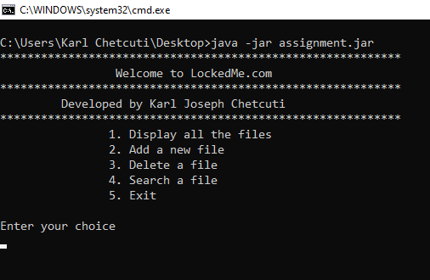

Figure 1 Main Display menu can be seen above.

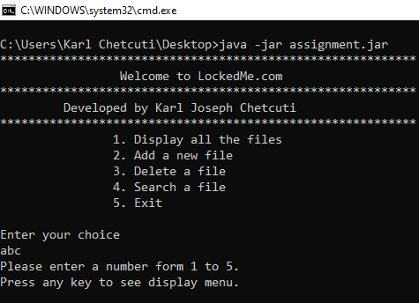

Figure 2 If the input is not an integer error handling will issue an error "Please enter a number from 1 to 5" and the program will loop unless integer 5 is inputted.

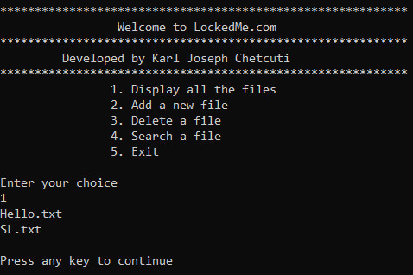

Figure 3 When inputting 1 all files in the folder path will be shown.

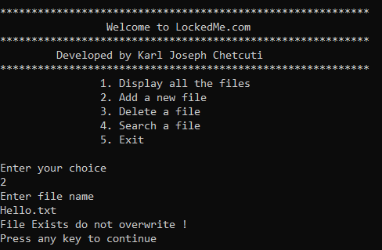

Figure 4 Program will not allow overwriting of file when inputting 2.

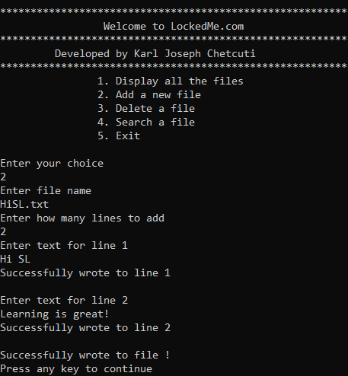

Figure 5 When inputting 2, a new file will be created which will not have a duplicate name.

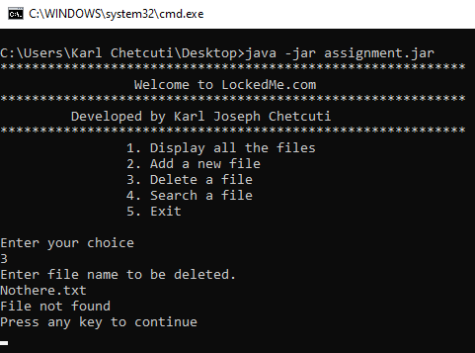

Figure 6 When inputting 3 only an existing file can be deleted. Else program will not allow deletion.

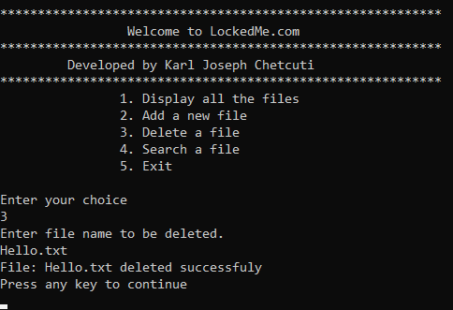

Figure 7 An existing file has been successfully deleted when inputting 3.

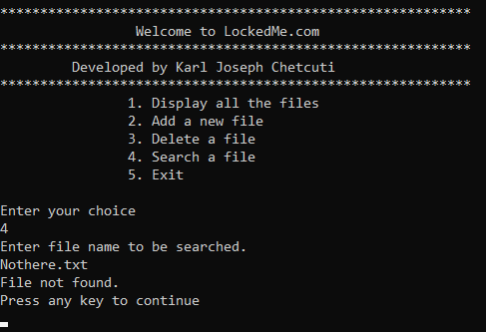

Figure 8 When inputting 4 an existing file name must be searched , else "File not found.".

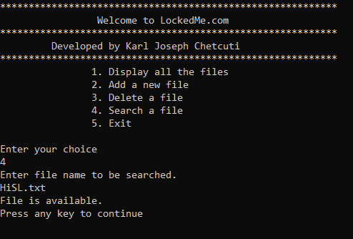

Figure 9 When inputting 4 an existing file name can be searched, and file will be found.